

Submitted By,
Name : Tasmia Hossain
ID : 20210204038
Section : A
Group : 1
Year/Semester : 4/1

Date of Submission : 27. 08. 2025
Submitted to ,
Saha Reno
Tahsina Muthaki
Course No : CSE 4142
Course Title : Data Warehousing and Mining Lab
Assignment 3
Department of Computer Science and Engineering
Ahsanullah University of Science and Technology

Introduction
In this assignment, the goal was to design and analyze market basket data using data mining techniques in Weka. A transactional dataset was created with 8 binary attributes representing products (Milk, Bread, Eggs, Butter, Rice, Chicken, Juice, Fruits) and 2 numeric attributes (PurchaseAmount, CustomerAge). Association rule mining was performed using the Apriori algorithm to uncover product co-occurrence patterns. Furthermore, the dataset was prepared for clustering, and K-Means clustering was applied to group customers based on purchasing behavior. This assignment provided hands-on experience in both association analysis and clustering techniques, which are widely used in real-world retail analytics.

Methodology
- Dataset Creation
A transactional dataset was created with 8 binary attributes (YES/NO) representing products, 2 numeric attributes and 50 transactions with realistic product combinations.
@relation MarketBasket

@attribute Milk {NO,YES}
@attribute Bread {NO,YES}
@attribute Eggs {NO,YES}
@attribute Butter {NO,YES}
@attribute Rice {NO,YES}
@attribute Chicken {NO,YES}
@attribute Juice {NO,YES}
@attribute Fruits {NO,YES}
@attribute PurchaseAmount numeric
@attribute CustomerAge numeric

@data
YES,NO,YES,NO,YES,NO,YES,NO,500,25
NO,YES,YES,YES,NO,YES,NO,YES,1200,33
YES,YES,NO,YES,YES,NO,NO,NO,800,28
YES,YES,YES,NO,NO,NO,YES,YES,950,31
NO,YES,YES,YES,YES,YES,NO,NO,1500,42
YES,NO,NO,YES,NO,NO,YES,YES,600,23
NO,YES,YES,NO,YES,NO,YES,YES,700,35
YES,YES,NO,YES,NO,YES,NO,YES,1300,40
NO,NO,YES,YES,YES,NO,NO,YES,900,27
YES,YES,YES,YES,NO,NO,NO,NO,750,30
NO,YES,NO,NO,YES,YES,YES,NO,1400,45
YES,NO,YES,YES,NO,NO,YES,NO,650,22
NO,YES,YES,NO,YES,NO,NO,YES,820,29
YES,YES,NO,NO,NO,YES,YES,YES,1550,38
NO,NO,YES,YES,YES,YES,NO,NO,1200,34
YES,YES,YES,YES,NO,NO,NO,YES,980,26
NO,YES,NO,YES,YES,YES,YES,NO,1450,36
YES,NO,YES,NO,YES,NO,NO,YES,500,21
NO,YES,YES,YES,NO,YES,NO,YES,1350,41
YES,YES,NO,NO,YES,NO,YES,NO,720,24
NO,NO,YES,YES,NO,YES,NO,YES,1100,39
YES,YES,YES,NO,YES,NO,YES,YES,870,32
NO,YES,NO,YES,YES,YES,NO,NO,1600,47
YES,NO,YES,YES,NO,NO,YES,NO,600,22
NO,YES,YES,NO,YES,NO,YES,YES,820,29
YES,YES,NO,YES,NO,YES,NO,YES,1300,40
NO,NO,YES,YES,YES,NO,NO,YES,900,27
YES,YES,YES,YES,NO,NO,NO,NO,750,30
NO,YES,NO,NO,YES,YES,YES,NO,1400,45
YES,NO,YES,YES,NO,NO,YES,NO,650,22
NO,YES,YES,NO,YES,NO,NO,YES,820,29
YES,YES,NO,NO,NO,YES,YES,YES,1550,38
NO,NO,YES,YES,YES,YES,NO,NO,1200,34
YES,YES,YES,YES,NO,NO,NO,YES,980,26
NO,YES,NO,YES,YES,YES,YES,NO,1450,36
YES,NO,YES,NO,YES,NO,NO,YES,500,21
NO,YES,YES,YES,NO,YES,NO,YES,1350,41
YES,YES,NO,NO,YES,NO,YES,NO,720,24
NO,NO,YES,YES,NO,YES,NO,YES,1100,39
YES,YES,YES,NO,YES,NO,YES,YES,870,32
NO,YES,NO,YES,YES,YES,NO,NO,1600,47
YES,NO,YES,YES,NO,NO,YES,NO,600,22
NO,YES,YES,NO,YES,NO,YES,YES,820,29
YES,YES,NO,YES,NO,YES,NO,YES,1300,40
NO,NO,YES,YES,YES,NO,NO,YES,900,27
YES,YES,YES,YES,NO,NO,NO,NO,750,30
NO,YES,NO,NO,YES,YES,YES,NO,1400,45
YES,NO,YES,YES,NO,NO,YES,NO,650,22
NO,YES,YES,NO,YES,NO,NO,YES,820,29
YES,YES,NO,NO,NO,YES,YES,YES,1550,38
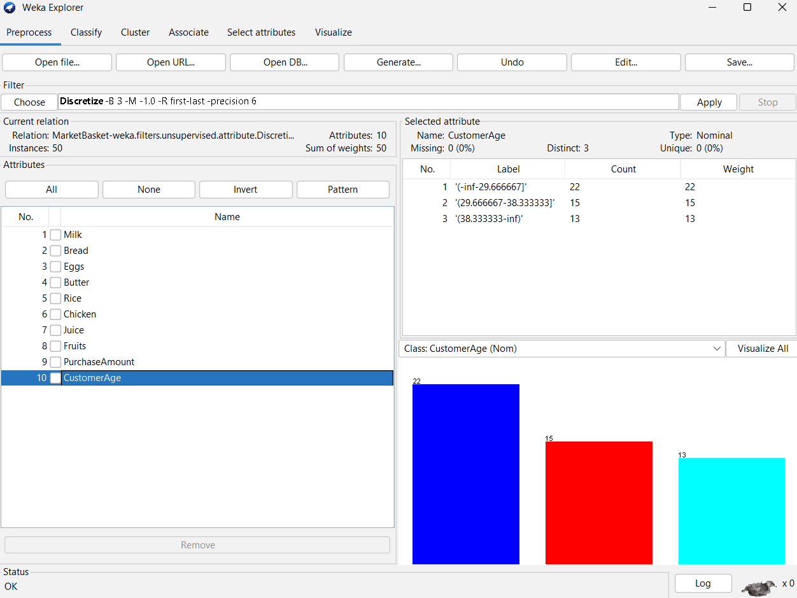

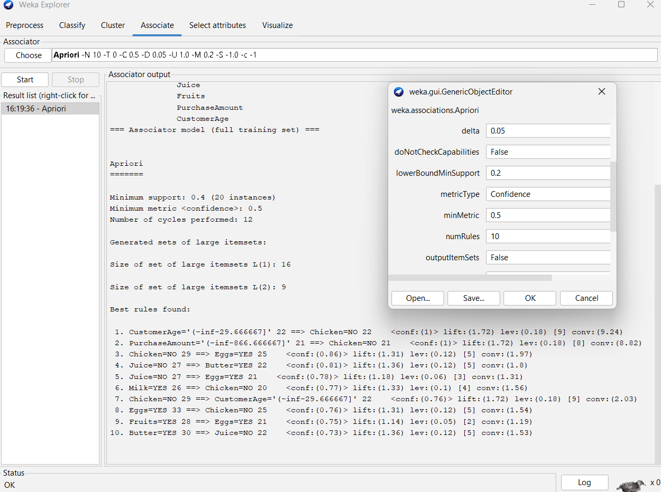
- Association Rule Mining (Apriori)
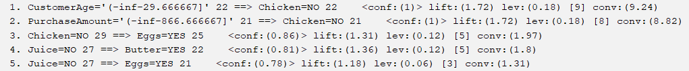
The dataset was analyzed using the Apriori algorithm in Weka under the Associate tab. The parameters were configured with a minimum support of 0.2 and a minimum confidence of 0.5. Apriori generated several association rules, from which the 5 strongest rules (highest confidence) were selected.

- Prepare Data for Clustering
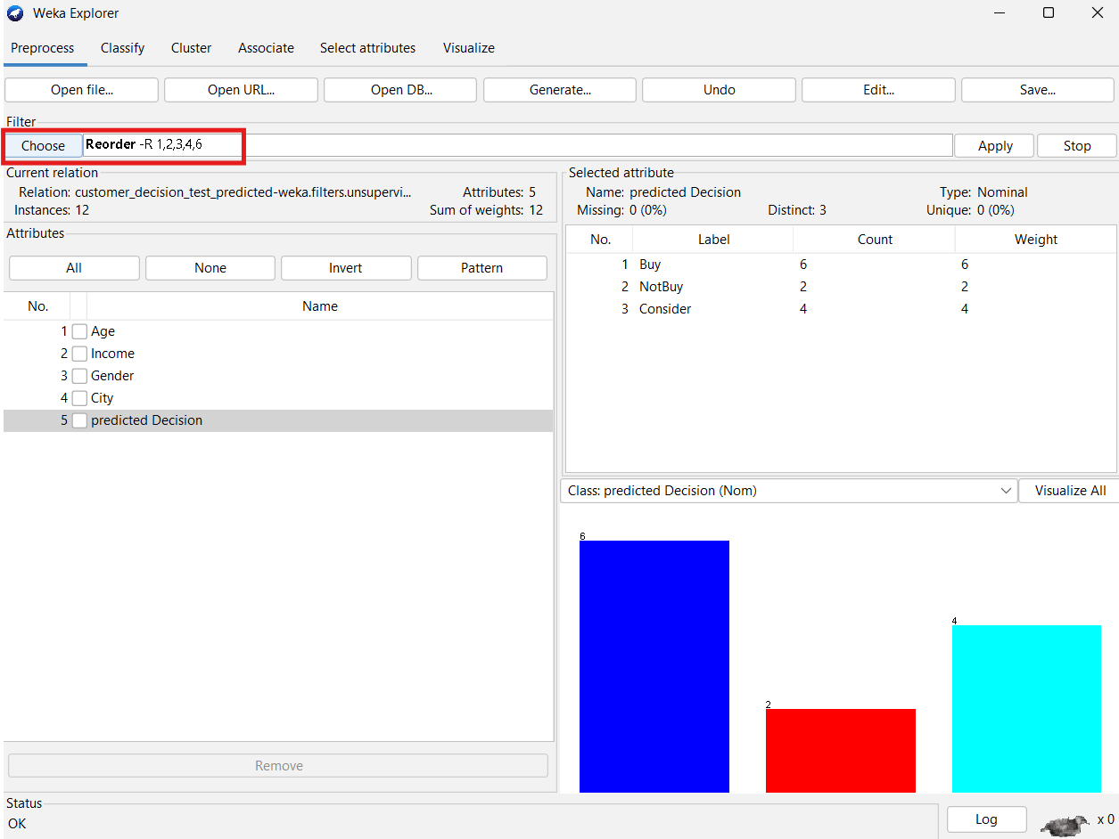
To prepare the data for clustering, the three most frequently occurring products identified in the Apriori rules (Eggs, Butter, Chicken) were selected. These attributes were combined with the two numeric variables (PurchaseAmount and CustomerAge). The binary product attributes were converted from nominal (YES/NO) to numeric (1/0) using Weka’s NominalToBinary filter, ensuring compatibility with clustering algorithms.
@relation 'MarketBasket-weka.filters.unsupervised.attribute.Remove-V-R3,4,6,9,10-weka.filters.unsupervised.attribute.NominalToBinary-R1,2,3'

@attribute Eggs=YES numeric
@attribute Butter=YES numeric
@attribute Chicken=YES numeric
@attribute PurchaseAmount numeric
@attribute CustomerAge numeric

@data
1,0,0,500,25
1,1,1,1200,33
0,1,0,800,28
1,0,0,950,31
1,1,1,1500,42
0,1,0,600,23
1,0,0,700,35
0,1,1,1300,40
1,1,0,900,27
1,1,0,750,30
0,0,1,1400,45
1,1,0,650,22
1,0,0,820,29
0,0,1,1550,38
1,1,1,1200,34
1,1,0,980,26
0,1,1,1450,36
1,0,0,500,21
1,1,1,1350,41
0,0,0,720,24
1,1,1,1100,39
1,0,0,870,32
0,1,1,1600,47
1,1,0,600,22
1,0,0,820,29
0,1,1,1300,40
1,1,0,900,27
1,1,0,750,30
0,0,1,1400,45
1,1,0,650,22
1,0,0,820,29
0,0,1,1550,38
1,1,1,1200,34
1,1,0,980,26
0,1,1,1450,36
1,0,0,500,21
1,1,1,1350,41
0,0,0,720,24
1,1,1,1100,39
1,0,0,870,32
0,1,1,1600,47
1,1,0,600,22
1,0,0,820,29
0,1,1,1300,40
1,1,0,900,27
1,1,0,750,30
0,0,1,1400,45
1,1,0,650,22
1,0,0,820,29
0,0,1,1550,38

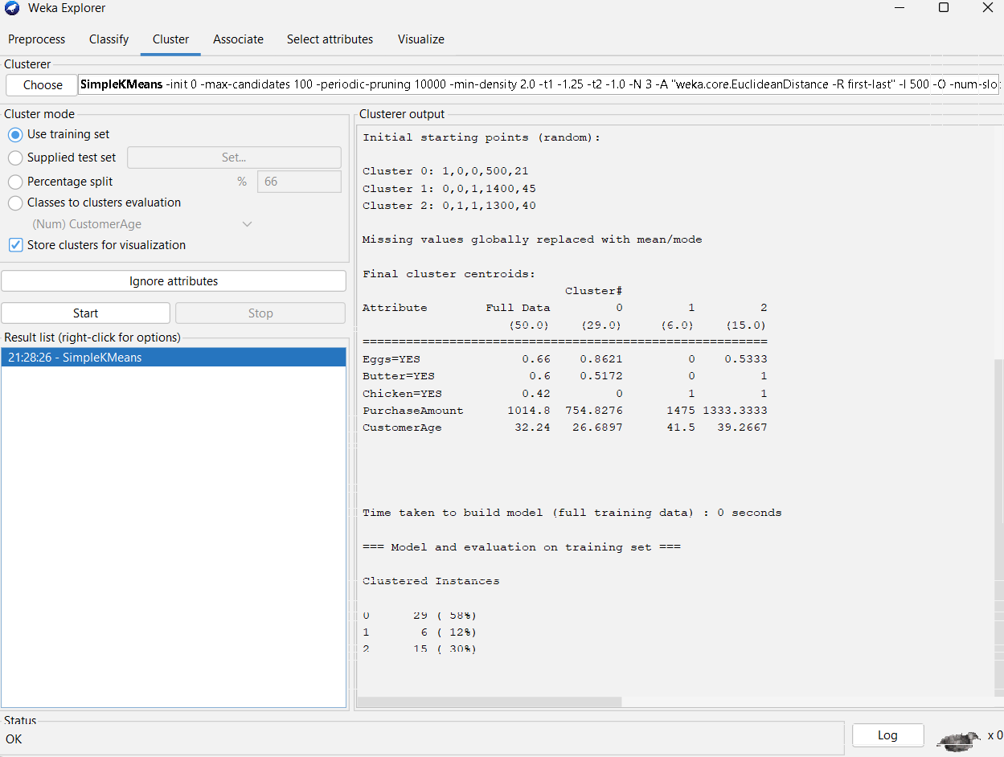
- K-Means Clustering
@relation 'MarketBasket-weka.filters.unsupervised.attribute.Remove-V-R3,4,6,9,10-weka.filters.unsupervised.attribute.NominalToBinary-R1,2,3_clustered'

@attribute Instance_number numeric
@attribute Eggs=YES numeric
@attribute Butter=YES numeric
@attribute Chicken=YES numeric
@attribute PurchaseAmount numeric
@attribute CustomerAge numeric
@attribute Cluster {cluster0,cluster1,cluster2}

@data
0,1,0,0,500,25,cluster0
1,1,1,1,1200,33,cluster2
2,0,1,0,800,28,cluster0
3,1,0,0,950,31,cluster0
4,1,1,1,1500,42,cluster2
5,0,1,0,600,23,cluster0
6,1,0,0,700,35,cluster0
7,0,1,1,1300,40,cluster2
8,1,1,0,900,27,cluster0
9,1,1,0,750,30,cluster0
10,0,0,1,1400,45,cluster1
11,1,1,0,650,22,cluster0
12,1,0,0,820,29,cluster0
13,0,0,1,1550,38,cluster1
14,1,1,1,1200,34,cluster2
15,1,1,0,980,26,cluster0
16,0,1,1,1450,36,cluster2
17,1,0,0,500,21,cluster0
18,1,1,1,1350,41,cluster2
19,0,0,0,720,24,cluster0
20,1,1,1,1100,39,cluster2
21,1,0,0,870,32,cluster0
22,0,1,1,1600,47,cluster2
23,1,1,0,600,22,cluster0
24,1,0,0,820,29,cluster0
25,0,1,1,1300,40,cluster2
26,1,1,0,900,27,cluster0
27,1,1,0,750,30,cluster0
28,0,0,1,1400,45,cluster1
29,1,1,0,650,22,cluster0
30,1,0,0,820,29,cluster0
31,0,0,1,1550,38,cluster1
32,1,1,1,1200,34,cluster2
33,1,1,0,980,26,cluster0
34,0,1,1,1450,36,cluster2
35,1,0,0,500,21,cluster0
36,1,1,1,1350,41,cluster2
37,0,0,0,720,24,cluster0
38,1,1,1,1100,39,cluster2
39,1,0,0,870,32,cluster0
40,0,1,1,1600,47,cluster2
41,1,1,0,600,22,cluster0
42,1,0,0,820,29,cluster0
43,0,1,1,1300,40,cluster2
44,1,1,0,900,27,cluster0
45,1,1,0,750,30,cluster0
46,0,0,1,1400,45,cluster1
47,1,1,0,650,22,cluster0
48,1,0,0,820,29,cluster0
49,0,0,1,1550,38,cluster1
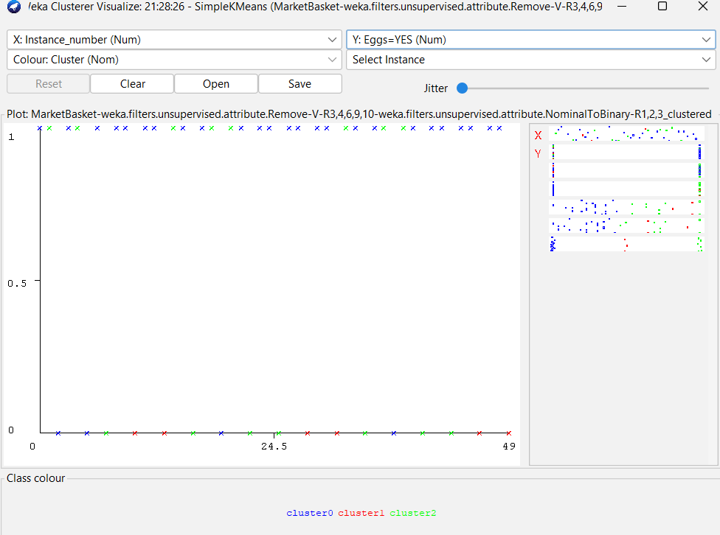
Result Analysis
The Apriori algorithm revealed strong product associations, such as “Eggs and Butter ⇒ Chicken”, reflecting realistic co-purchase behavior. The top five rules highlighted frequent product correlations useful for cross-selling strategies.
K-Means clustering (using Eggs, Butter, Chicken, PurchaseAmount, and CustomerAge) grouped customers into three segments:
- Cluster 0: Younger, low-spending customers with fewer purchases.
- Cluster 1: Older, high-spending customers, strongly linked to Chicken.
- Cluster 2: Middle-aged, moderate to high spenders buying Eggs and Butter with Chicken.
These results show how association mining and clustering together provide actionable insights for retail decision-making.

Conclusion
This assignment demonstrated how Apriori can uncover meaningful product associations and how K-Means can segment customers into distinct groups. Together, these techniques provide valuable insights for cross-selling, targeted marketing, and customer profiling in retail analytics.

